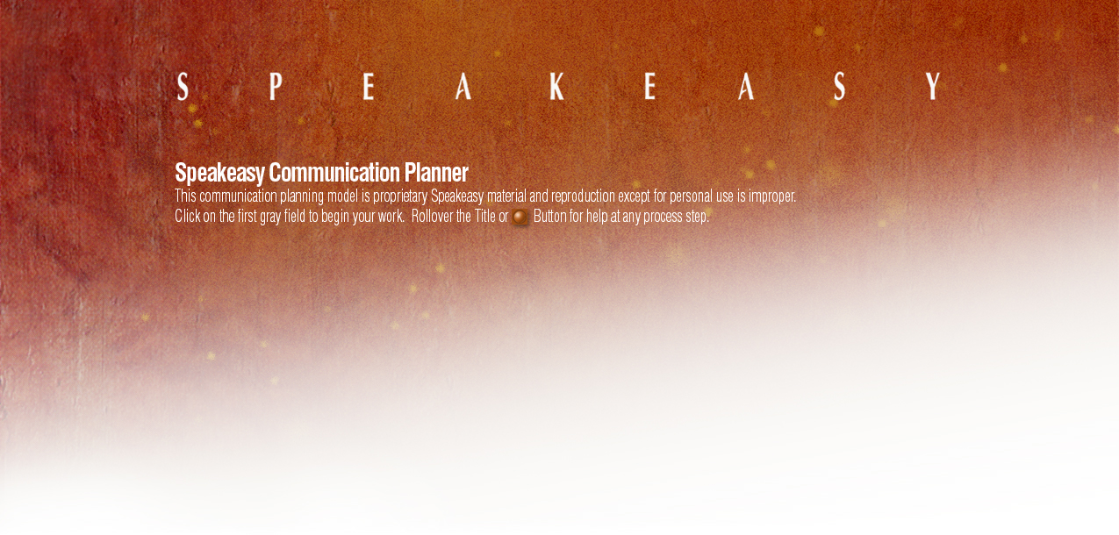

**Listener(s) / Situation:**

**Point X / Destination:**



|  |
| --- |
| “When I’m finished my listener(s) will … |

Unstated (hidden) X:



|  |
| --- |
| Personal:  Business: |

**Listener’s Current Reality** (Facts, Assumptions):



|  |
| --- |
|  |

**Revised Point X**



|  |
| --- |
| When I’m finished my listener(s) will … |

**Message** Visuals



|  |  |
| --- | --- |
|  |  |

**Body** Visuals



|  |  |
| --- | --- |
| Question 1:  Answer:  Subpoint:  Question 2:  Answer:  Subpoint:  Question 3:  Answer:  Subpoint:  Question 4:  Answer:  Subpoint:  Question 5:  Answer:  Subpoint: |  |

**Opening**  Visuals



|  |  |
| --- | --- |
|  |  |

**Closing**  Visuals



|  |  |
| --- | --- |
|  |  |